Smart Excess Food & Clothes Donation System

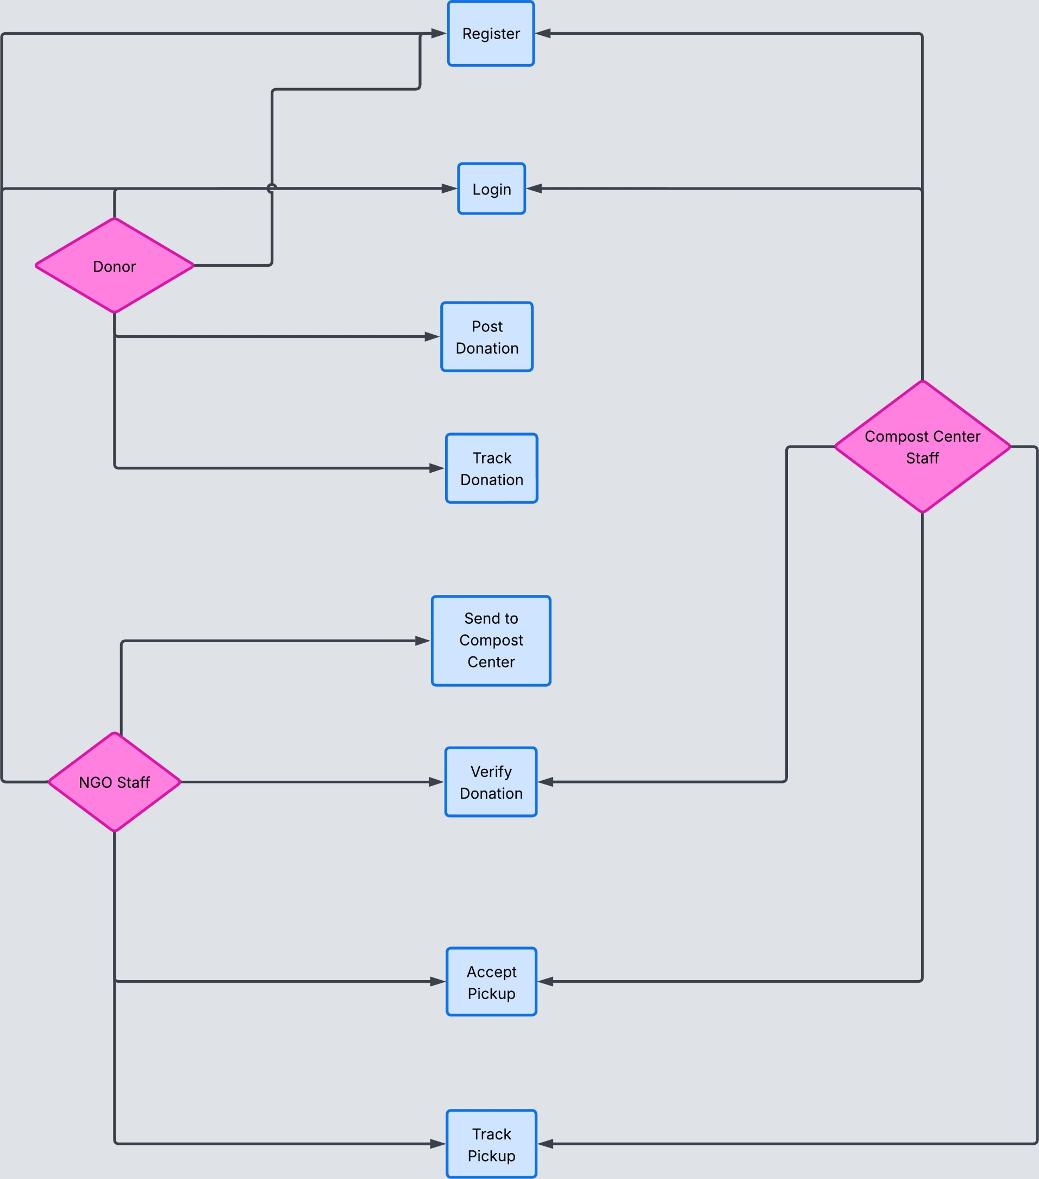
This diagram illustrates the functional interaction between the system and its three primary actors: Donor, NGO Staff, and Compost Center Staff. It represents the overall workflow of the Smart Excess Food & Clothes Donation System within the system boundary.

Actors & Roles:
➤ Donor:
The donor is responsible for registering and logging into the system to donate excess food or usable clothes. The donor can post donation details, track donation status, and receive notifications. Spoiled food can be directly sent to the compost center, while edible food and usable clothes are forwarded to NGOs.
➤ NGO Staff:
NGOs verify and accept donations from donors. They collect edible food and usable clothes for distribution. If any collected food is found to be spoiled, it is forwarded to the compost center. NGOs can track pickups and view donation history.
➤ Compost Center Staff:
The compost center handles spoiled food received either directly from donors or through NGOs. They accept pickup requests, process composting, and update the system once composting is completed.

